David Villa
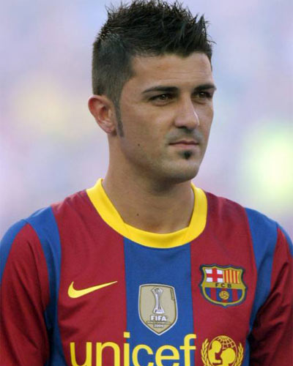
His full name is David Villa Zánder. He was born December 3th 1981 in Spain in the city of Tuilla. He is a football player now playing for FC Barcelona. He plays on offence. He scored 166 goals when he was playing for Valencia between the years 2005-2010. He represents Spain in football. Some people say that he is the best offensive player. He wears a jersey with number 7.

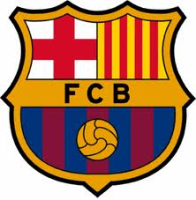
Barcelona
FC Barcelona is a name of a football club. Some people, usually its fans, call it ‘’Barca’’. The Club was founded in 1899. The team has trainings at the Nou Camp stadium. The capacity of the stadium is 98 700. Nowadays the coach of Barcelona is Josep Guardiola. There aren’t only football clubs in Barcelona but there are other clubs (basketball) as well. The slogan of the club is:’’ El Barca és més que un club.’’ In translations it means:’’ Barca is not only a club.’’ The biggest rival of Barcelona is Real Madrid. In 2009 Barcelona won the Champions League trophy.
Svoji fotbalovou kariérou zahájil ve španělském klubu UP Langreo. V roce 1999 jej koupil Sporting Gijón, kde se postupně propracoval do A týmu. O 4 roky později okusil poprvé španělskou nejvyšší soutěž v dresu Realu Zaragoza. Hned v první sezoně pomohl Zaragoze k zisku Španělského poháru zvaného Copa del Rey a následně i k vítězství v superpoháru proti Realu Madrid. Strávil zde ještě jednu sezónu a odešel do Valencie za odstupné 12 milionu eur. Táké se každý rok dostane do hry FIFA.
