Freestyle scootering
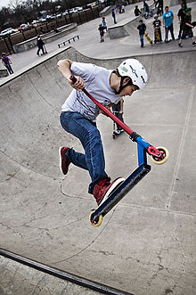
Freestyle scootering is a sport discipline. It is about doing good tricks. The terminology is similar as in BMX(biking). You can do freestyle scootering almost everywhere. You need a good surface to scooter on. A scooter does not work on sand for example. Usually it is younger people who do freestyle scootering.

I do freestyle scootering too. I have been doing it for only 7 months. The brand of my scooter is District, it is a French brand. I think that freestyle scootering is easier than skating or BMX.
You can buy a feestyle scooter at výstaviště in the Gizmania shop. Gizmania was the first scooter shop in Europe. My scooter is from Gizmania too. My scooter cost 6000 crowns. One of the best Czech scooter-riders is Petr Macháček. His scooter costs about 13 000 crowns.
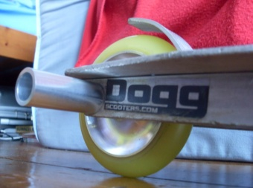
There are a lot of components for freestyle scooter. Pegs are components that you can put on or put off the scooter. They are used for grinding.
Some Tricks:
Tel vip – you jump and turn the desk around
Bar spin –you jump and turn the handlebars around
Bunny hop - a simple jump
Grind – Slide
Back\Front flip – you jump and rotate with your whole body and with the scooter in the air backwards
Front Bree – it is hard

My scooter:
I have my scooter 3 months. The brand of them is district. It is much funny.
My desk is district, bars, grips and brake, but my sleeve is French ID and wheels are MGP.
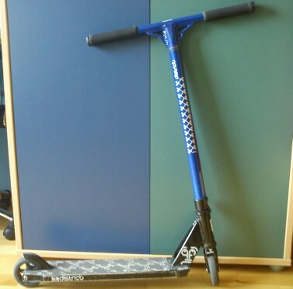

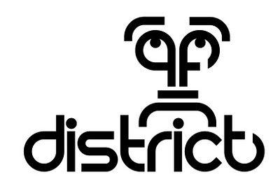
Some brand :

